

|  |  |  |  |  |  |  |  |  |
| --- | --- | --- | --- | --- | --- | --- | --- | --- |
|  | | | | | | | | |
|  | | SMART DUSTBIN | | | | |  | |
|  |  | | | | | | |  |
|  | | | |  |  | | | |
|  | | | | FADY SAMY 18102062ROWAN MOHAMED 18100940MOHAMED ASHRAF 18101303REEM MOSTAFA 18102241 |  | | | |
|  | | | | 22/12/2022Advanced Networks—Eng. AHMED HATEM |  | | | |
|  | | |  | | |  | | |



|  |  |  |  |  |  |  |  |  |
| --- | --- | --- | --- | --- | --- | --- | --- | --- |
|  |  | | |  |  | | |  |
|  | SUMMARY | | | | | | |  |
|  |  | | |  |  | | |  |
|  |  | |  | | |  | |  |
|  |  |  | This project involves working in a team to design and build a smart dustbin system designed to implement MQTT protocol that allows lightweight and publish-subscribe messaging. This dustbin is made from recycled materials to help people specially the disabled while throwing stuff without having to physically interact with the dustbin in addition to getting notifications when the dustbin is full and needs to be emptied. GUI is made with react native application. | | |  |  |  |
|  | | | | |
|  |  |  |  |
|  |  |



##### Problem statement:

This project aims to help paralyzed people to deal with dustbins without having to open it with their legs or hands and only moving any part of their body.

##### USED PROTOCOL and WHY?

* MQTT protocol is used as the information is sent between the client and the server via a publish/subscribe messaging protocol that is intended to be straightforward and lightweight.
* It is not necessary for the client and server to establish a connection simultaneously.
* It offers quicker data transfer, similar to how WhatsApp or Messenger offers quicker delivery. Real-time communications protocol, that is.
* Uses TCP/IP transmission protocol
* In order to acquire the information needed, it enables clients to subscribe to a specified group of themes.

##### hardware

* IR sensor: Used for hand detection to open the dustbin
* Servo motor: used to open the dustbin when IR signal is on
* Ultrasonic sensor: used to detect if the dustbin is full from the inside
* Node MCU ESP8266 with WiFi module.

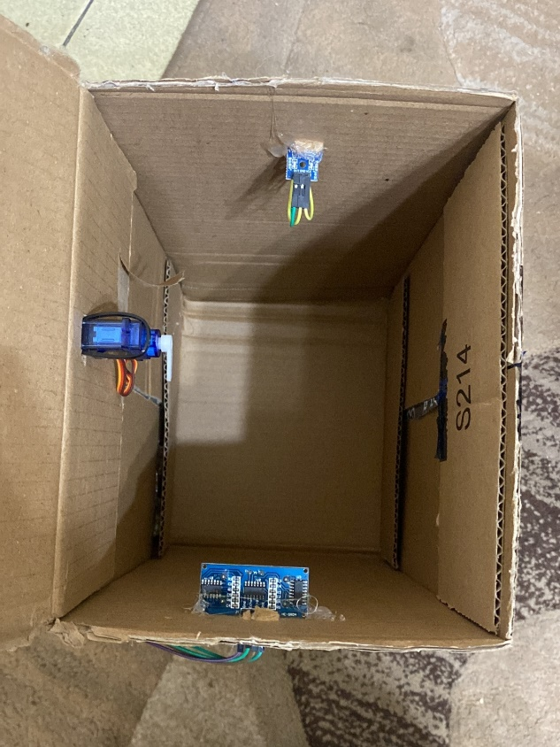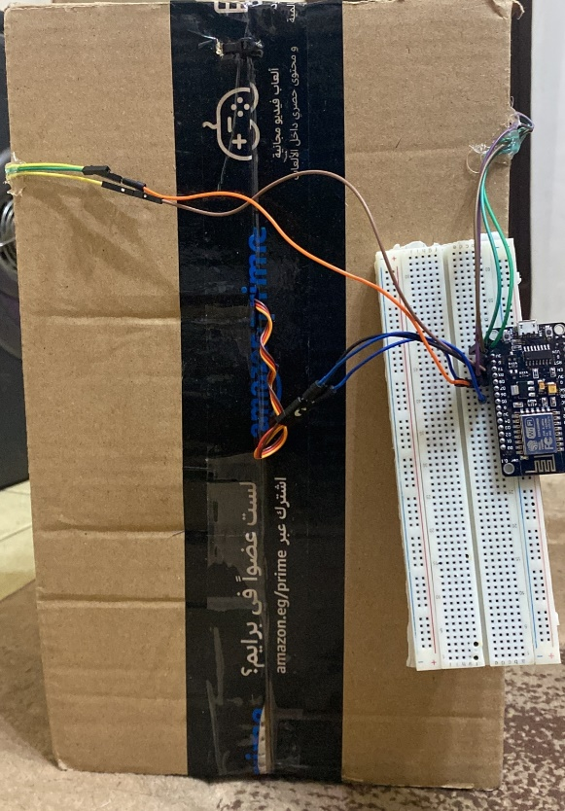

##### 

##### DUSTBIN:

|  |  |  |  |  |  |  |
| --- | --- | --- | --- | --- | --- | --- |
|  | |  |  |  |  | |
|  | Why Node.JS : Node.Js is an open supply, cross-platform runtime environment and library that is used for going for walks internet programs outside the client’s browser.  It's miles used for server-side programming, and basically deployed for non-blockading, occasion-driven servers, along with traditional net websites and lower back-quit API offerings, but was at the start designed with real-time, push-primarily based architectures in thoughts. Every browser has its personal version of a JS engine, and node.Js is constructed on Google Chrome’s V8 JavaScript engine. | | | | |  |

##### codes:

